

**SunSystems**

**Data Refresh Process**

Document

Document: **Infor© SunSystems 6.3 Test Refresh**

Client:

Prepared by: **Cihan Acikgoz**

Version: **1.3**

Date: **November 2019**

# CONTENTS

CONTENTS 2

1 DOCUMENT CONTROL SUMMARY 3

1.1 Version Control Summary 3

1.2 Reviewers 3

2 Prerequisites 4

3 Running the Data Refresh Process 5

3.1 Export SunSystems Configuration from Deploy Manager 5

3.2 Stop All SunSystems Services 8

3.3 Restore the Databases 8

3.4 Enable SQL Broker 9

3.5 Clear opened sessions from SunSystemsDomain database 10

3.6 Relink SunSystemsData to Domain 10

3.7 Select Security DB and Grant Windows Service Group 15

3.8 Re-configure SQL Reporting Service 17

3.9 Running the Database Update Scripts 22

3.10 Start SunSystems Security Service 22

3.11 Import SunSystems Configuration 22

3.12 Run Deploy Agent 25

3.13 Serialization 28

3.14 Bring BU Online 29

3.15 Update Data Send URL 30

4 Appendix A: SQL Update Scripts 30

# DOCUMENT CONTROL SUMMARY

## Version Control Summary

| **Date** | **Version** | **Produced By** | **Details** |
| --- | --- | --- | --- |
|  | 1.1 | Cihan Acikgoz | Doc created |
|  |  |  |  |
|  |  |  |  |

## Reviewers

| **Date** | **Name** | **Company** |
| --- | --- | --- |
|  |  |  |
|  |  |  |

# Prerequisites

The following prerequisites are required for the successful refresh of the Infor© SunSystems data within additional environments for Microsoft© SQL Server platforms.

The following details are correct at the time of documentation, (20/11/19), and does not cover any subsequent changes made by either Sapphire consulting services or third party companies.

* Full local administrator rights on the Microsoft© SQL Server instance hosting the Infor© SunSystems (6.3) databases on which the update is to be performed.

* Full sysadmin permissions to the Microsoft© SQL Server instance.
* Access to the Infor© SunSystems (6.3) installation binaries to execute the Database Utilities module.
* Full backups restored for the following Infor© SunSystems (6.3) databases. (SunSystemsSecurity, SunSystemsDomain, SunSystemsData, SunSystemsSRS and SunSystemsSSRSTempDB)
* Full network connectivity between Microsoft© SQL Server, Infor© SunSystems (6.3) application servers and client machine.
* An Infor© SunSystems (6.3) environment using the same patch level (SunSystems) to the live environment.
* An Infor© Query & Analysis (10.1.x) installed on DR or test system.

# 

# Running the Data Refresh Process

The following section highlights the steps required in order to update data loaded onto the Test server from the live database server instance. All required files and software is present on the Test server, locations are referred to throughout the documentation.

**NOTE: all processes referred to in this documentation are to be initiated solely on the Test servers.**

## Export SunSystems Configuration from Deploy Manager

The following section highlights how to export configuration settings of SunSystems.

**Important Note**: Once the configuration settings are exported as zip format. Please keep the configuration zip file saved on the server or File Server.

**“**Once the export is done**, this task can be skipped on the next Data Refreshment can be used. Importing configuration has been detailed on section 3.10 ( Import SunSystems Configuration from Deploy Manager ) “**

On SunSystems Server, click Windows Start Menu > Infor > Deploy Manager

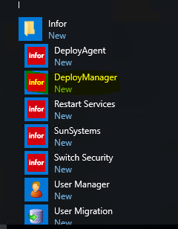

Login related username and password



Click Function > Environment Migration

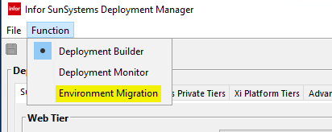

Click “ Export “ button

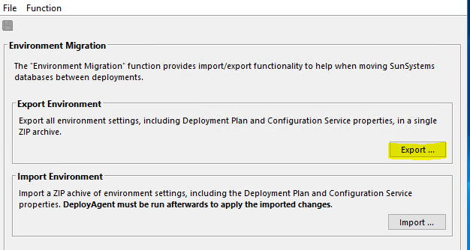

Save the configuration File the appreciated location on the server or Network File Server and add the UAT servername beginning of zip file.

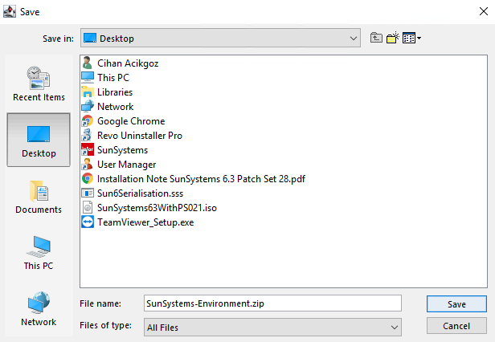

## Stop All SunSystems Services

Stop below services under services.msc

| **Service Name** | **Server Location** |
| --- | --- |
| SunSystems Configuration Service |  |
| SunSystems Web Service |  |
| SunSystems Connect Server |  |
| SunSystems Application Server |  |
| SunSystems Security Service |  |
| SunSystems Report Manager Service |  |
| SunSystems Api Service |  |
| SQL Reporting Service |  |
|  |  |
|  |  |
|  |  |

## Restore the Databases

**Note:**

**The below action should be carried by SQL DBA who has admin level knowledge of SQL Server.**

Restore below databases on UAT environment.

| **Database Name** |
| --- |
| SunSystemsSSRS |
| SunSystemsSSRSTempDB |
| SunSystemsData |
| SunSystemsDomain |
| SunSystemsSecurity |
| SunSystemsQA |
|  |
|  |

## Enable SQL Broker

**Note:**

**The below action should be carried by SQL DBA who has admin level knowledge of SQL Server.**

SQL Broker needs to be enabled per database. To do that;

* Right click one of database > Properties > Options
* Scroll down the bar and set Broker Enabled value as “ **True** “
* This task should be followed for SunSystemsDomain - SunSystemsSecurity and SunSystemsData

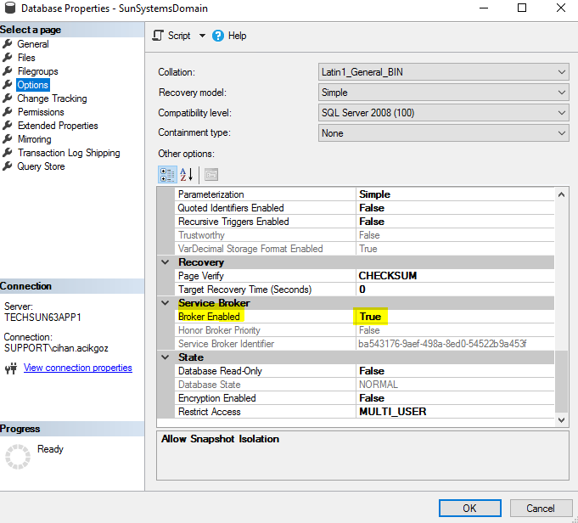

Note:

If the change throws an error message, that means database in use. Therefore, restart SQL Server to clean processes under SQL Server and then re-try to set Enable Broker as “ **True** “

## Clear opened sessions from SunSystemsDomain database

**Note***:**

**The below tasks should be carried by DBA.**

* Run below queries against SunSystemsDomain database

--Clear logged in users

USE SunSystemsDomain;

DELETE FROM DOMN_DB_OPR

USE SunSystemsDomain;

UPDATE DOMN_OPR SET LOGIN_IND = '0'

USE SunSystemsDomain;

UPDATE [SunSystemsDomain01].[dbo].[DOMN_DSRCE_CONFIG]

SET DBASE_INSTANCE = 'XXXX'

## Relink SunSystemsData to Domain

* Mount SqlServerDatabaseUtilitiesV7.iso from XXXXXXXXXXXXXXX
* Expand SqlServerDatabaseUtilities and double click DBUTILITY.EXE

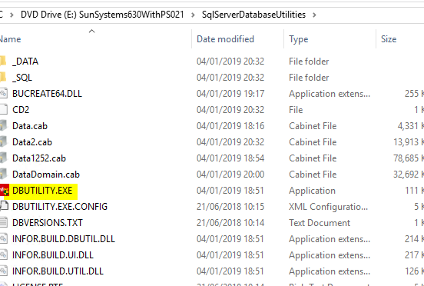

* Select Domain DB > Re-link all the SunSystems Business Unit Group to a SunSystems Domain option. Click Next.

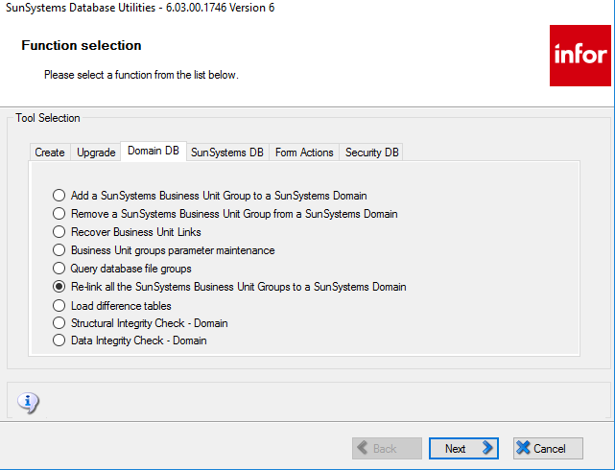

* Enter below details. Click Next
  + Instance Name : XXXXXX
  + Database Name : SunSystemsDomain

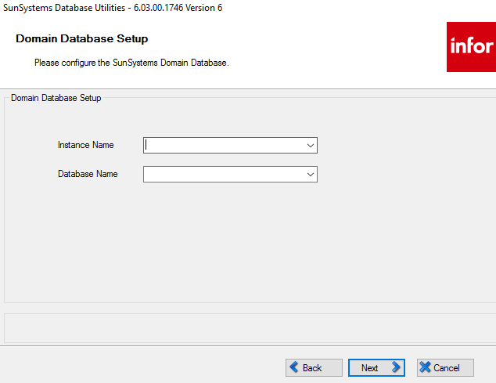

* Click Next

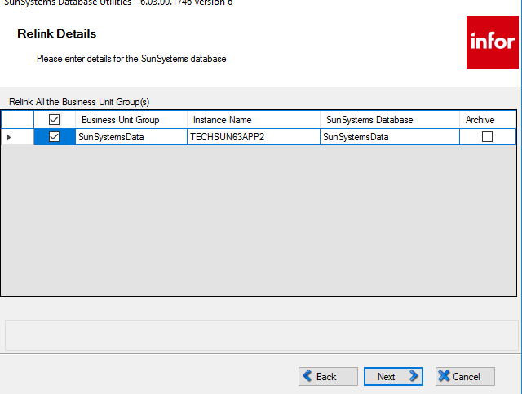

* Enter below details. Click Next
  + Administration Group Settings
    - Windows Domain : XXXX
    - Group Name : XXXX
  + Client Group Settings
    - Windows Domain : XXXX
    - Group Name : XXXX

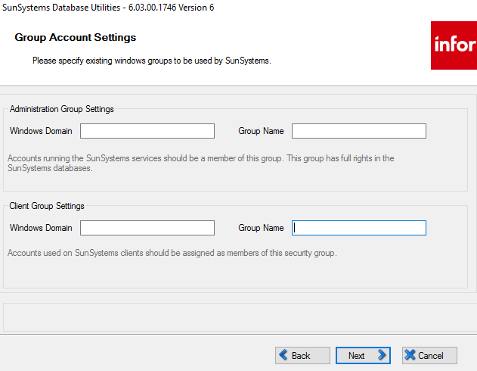

* Click Next to complete tasks. Make sure Progress Monitor completes successfully.
* Click Finish.

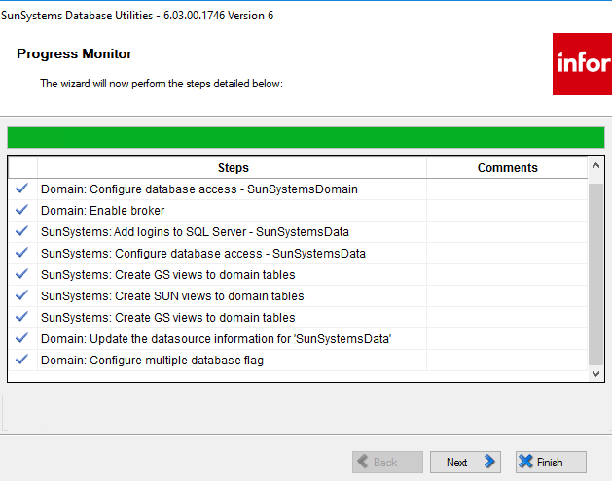

## Select Security DB and Grant Windows Service Group

* From the SqlServerDatabaseUtilitiesV7.iso from XXXXXXXXXXXXXXX
* Expand SqlServerDatabaseUtilities and double click DBUTILITY.EXE
* Select Security DB > Click Next

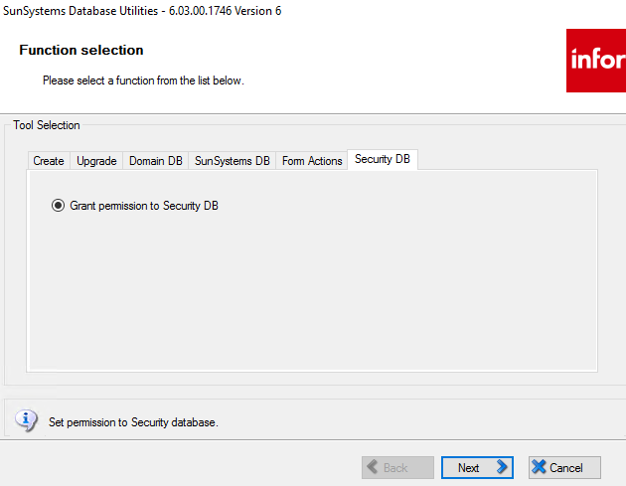

* Enter below details. Click Next.
  + Instance Name : XXXX
  + Database Name : XXXX
* Enter below details. Click Next
  + Administration Group Settings
    - Windows Domain : XXXX
    - Group Name : XXXX
  + Client Group Settings
    - Windows Domain : XXXX
    - Group Name : XXXX



* Click Next to complete tasks, then Click Finish.

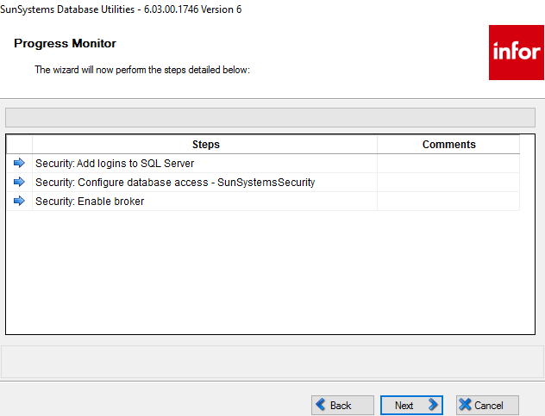

## Re-configure SQL Reporting Service

**Note***:**

**The below tasks should be carried by DBA.**

**Make sure Windows login to server is service account of SQL Reporting Service.**

* Open SQL Man. Studio and run the below query to delete encryption key of SQL Reporting Service.

USE SunSystemsSSRS

DELETE FROM KEYS WHERE MachineName='XXX'

1 row should be affected on result panel.

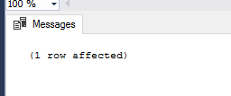

* Start SQL Reporting Service on XXXX server.
* Run Report Server Configuration Manager from Windows Menu.
* Click Connect

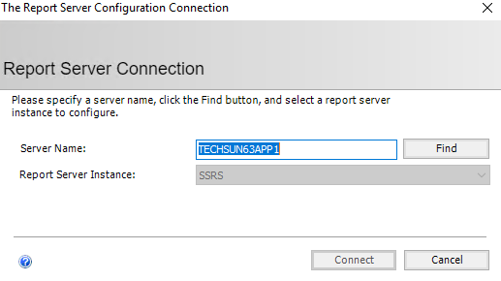

* Select “ Service Account “ tab.
* Re-type the password and click Apply button.

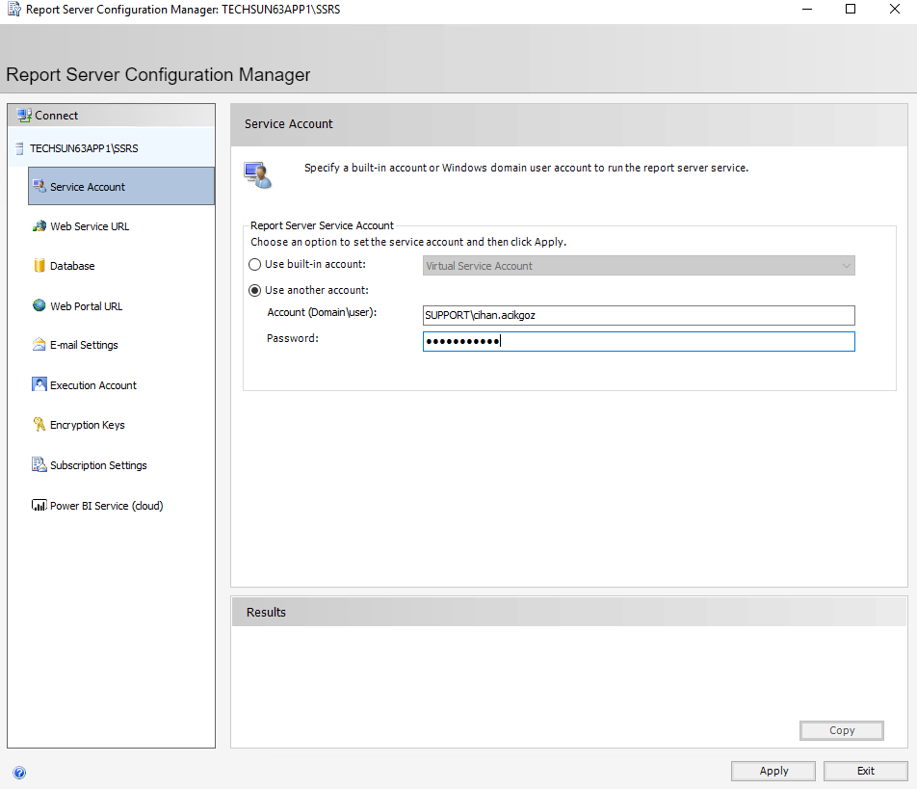

* Click “ … “ to define File Location. Give a name such as “ SSRS_KEY_NEW “ and then click “ Save “ button.

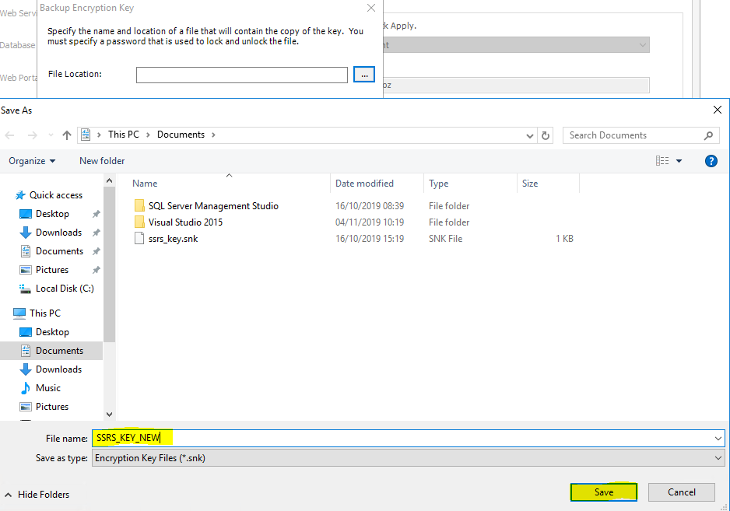

* Enter complex password minimum 8 characters, then click OK.

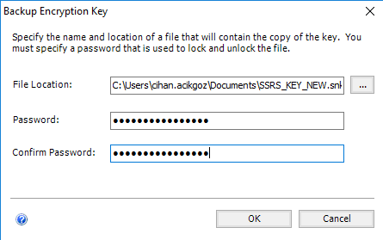

* Click OK

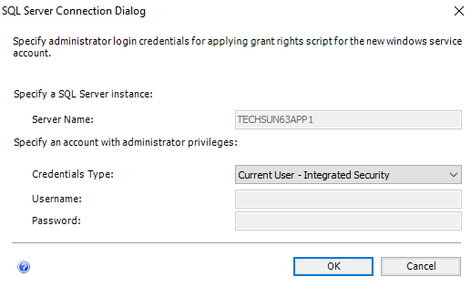

* Make sure Result Panel completed without any error message.
* Restart SQL Reporting Service from services.msc
* Click “ Web Service URL “
* Click the URL - <http://XXX:80/ReportServer>

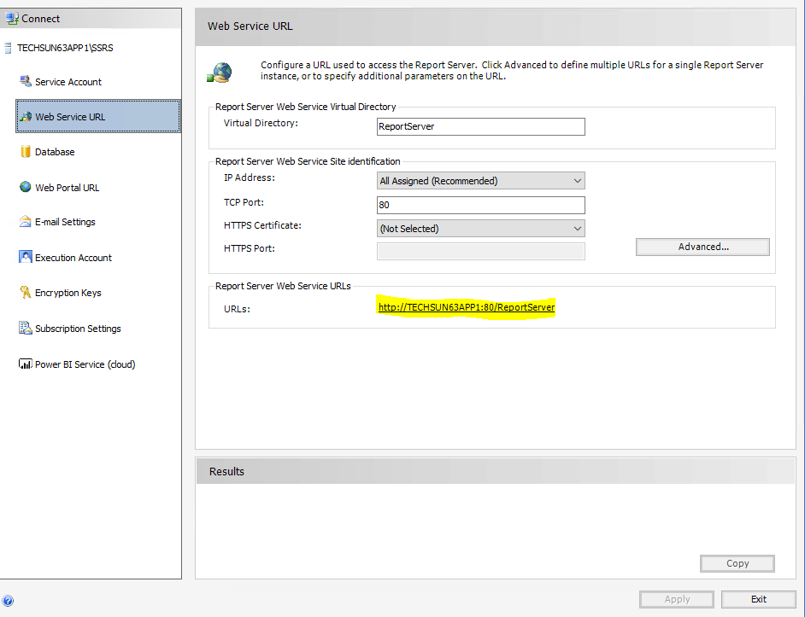

* Make sure web page loads successfully.
* Click “ Web Portal URL “
* Click the URL - <http://XXX:80/Reports>

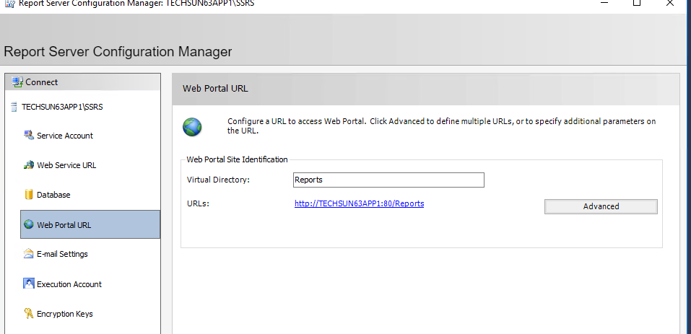

* Make sure web page loads successfully.

## Running the Database Update Scripts

**Note***:**

**The below tasks should be carried by DBA.**

* Open SQL Man. Studio
* Run below queries against SunSystemsSecurity database

UPDATE [SunSystemsSecurity].[dbo].[SCTY_PROPERTIES]

SET STRPROP = 'SunAppServername' WHERE PROPNAME='sun5.APP.config.hostName'

UPDATE [SunSystemsSecurity].[dbo].[SCTY_PROPERTIES]

SET STRPROP = 'SunAppServername' WHERE PROPNAME='sun5.REPORTING.config.hostName'

UPDATE [SunSystemsSecurity].[dbo].[SCTY_PROPERTIES]

SET STRPROP = 'SunAppServername' WHERE PROPNAME='sun5.WEB.config.hostName'

UPDATE [SunSystemsSecurity].[dbo].[SCTY_PROPERTIES]

SET STRPROP = 'SunWebServername' WHERE PROPNAME='sun5.config.hostName'

UPDATE [SunSystemsSecurity].[dbo].[SCTY_PROPERTIES]

SET STRPROP = 'SQLInstance' WHERE PROPNAME='db.server'

## Start SunSystems Security Service

* From services.msc – Start “ SunSystems Security Service “

## Import SunSystems Configuration

* From Windows menu > Infor > run Deploy Manager.

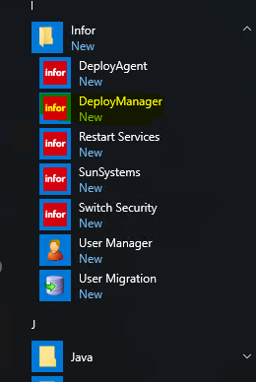

* Login with appreciated Username and password.



* Click Function > Select “ Environment Migration “

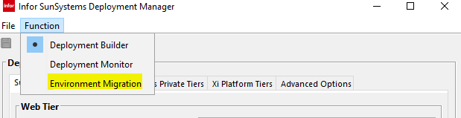

* Click “ Import “

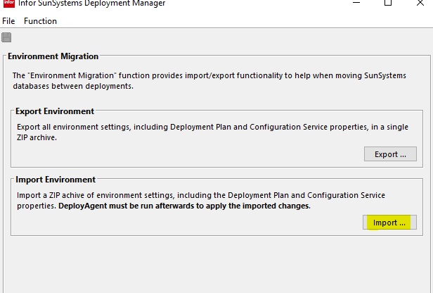

* Select the configuration zip file which was already exported and then click Open.

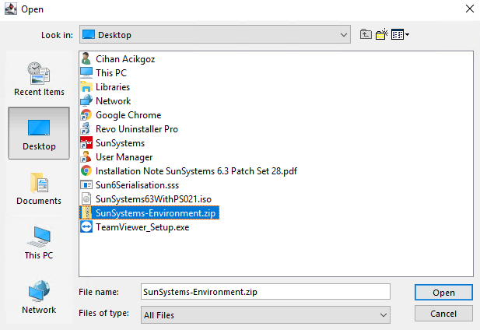

* Import will be completed successfully.
* Click OK and close the Deploy Manager tool.

## Run Deploy Agent

* From Windows Menu > Infor > Run DeployAgent

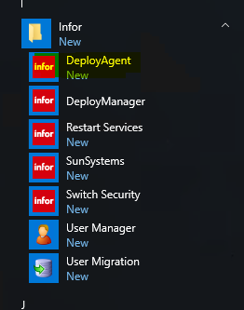

* Login with appreciated Username and password.

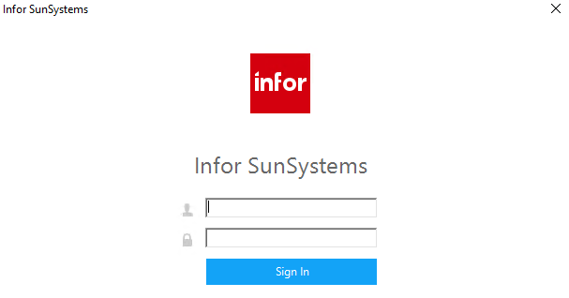

* Click “ Apply Deployment “ to start deployment.

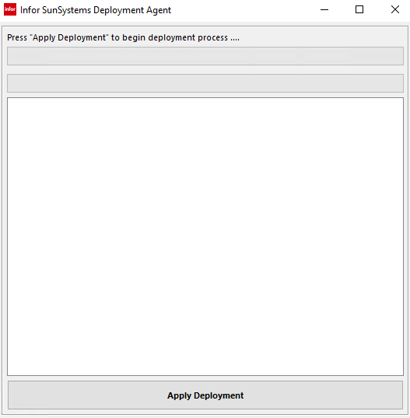

* Deployment completed successfully.

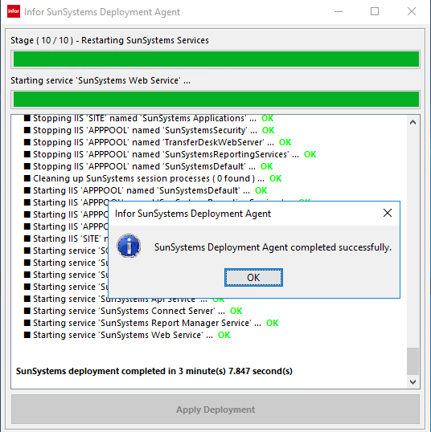

## Serialization

* Serilisation Location : \\XXX\Serialization\
* Double click the serialization file. ( Sun6Serialization.sss )
* Tick “ All Datasources “
* Serialization is completed.

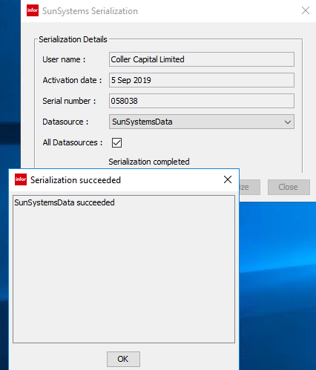

## Bring BU Online

Login to SunSystems and you may get a message that all BUs are offline. To bring them online go to BUA (Business Unit Administration)

You will notice SunSystemsData01 lines showing Offline Status. Now go to databases and run the following script in below;

Come back to BUA screen and click on Refresh button. You will notice the offline status would change to online.

* Then Click on **Explode All**, you will notice all Business Units may still be offline even though the top two levels are online.
* Then do the following to bring all BU online.
  + Click on the SunSystemsData01 line
  + Go to Action Menu at the top >> Click on **Put Online**

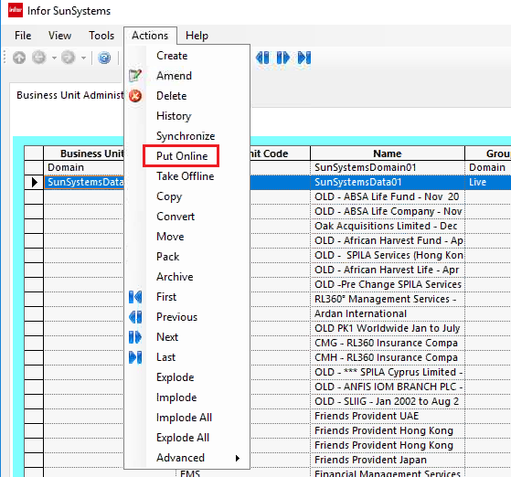

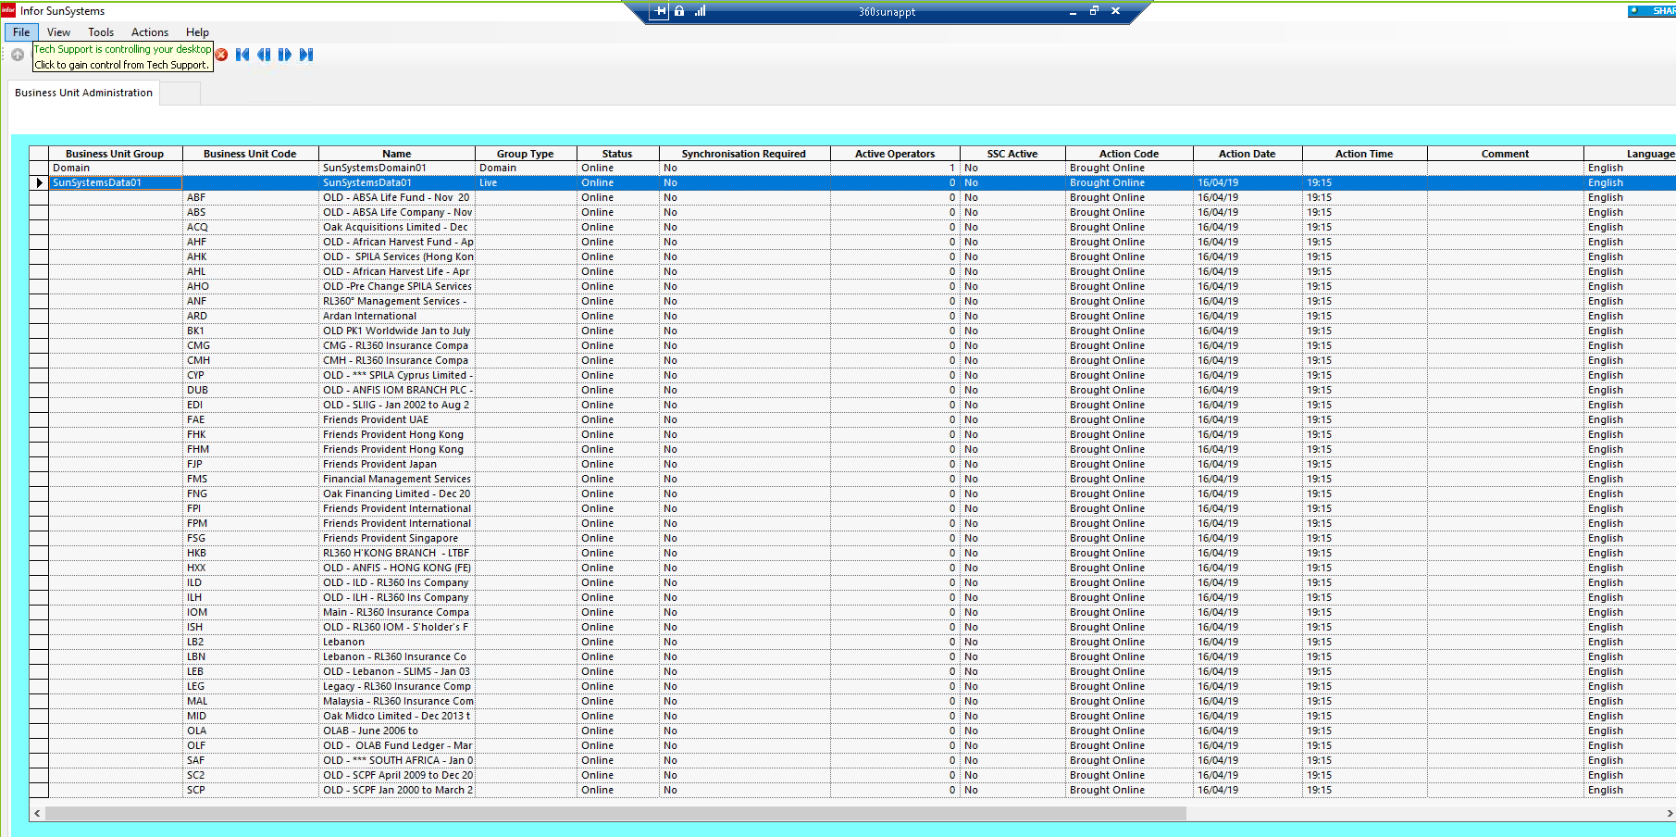

## Update Data Send URL

# Appendix A: SQL Update Scripts

The following section highlights the contents of the Microsoft SQL Update Script used to prepare the databases imported from live instance of Microsoft© SQL Server into the disaster recovery instance.

**SunSystems Tables Updates**

--Clear logged in users

USE SunSystemsDomain

DELETE FROM DOMN_DB_OPR

USE SunSystemsDomain

UPDATE DOMN_OPR SET LOGIN_IND = '0'

USE SunSystemsDomain;

UPDATE [SunSystemsDomain01].[dbo].[DOMN_DSRCE_CONFIG]

SET DBASE_INSTANCE = 'XXXX'

-- Delete old SSRS Servername

USE SunSystemsSSRS

DELETE FROM KEYS WHERE MachineName='XXX'

-- Update SunSystemsSecurity Db

UPDATE [SunSystemsSecurity].[dbo].[SCTY_PROPERTIES]

SET STRPROP = 'SunAppServername' WHERE PROPNAME='sun5.APP.config.hostName'

UPDATE [SunSystemsSecurity].[dbo].[SCTY_PROPERTIES]

SET STRPROP = 'SunAppServername' WHERE PROPNAME='sun5.REPORTING.config.hostName'

UPDATE [SunSystemsSecurity].[dbo].[SCTY_PROPERTIES]

SET STRPROP = 'SunAppServername' WHERE PROPNAME='sun5.WEB.config.hostName'

UPDATE [SunSystemsSecurity].[dbo].[SCTY_PROPERTIES]

SET STRPROP = 'SunWebServername' WHERE PROPNAME='sun5.config.hostName'

UPDATE [SunSystemsSecurity].[dbo].[SCTY_PROPERTIES]

SET STRPROP = 'SQLInstance' WHERE PROPNAME='db.server'